Class Activity: 10.07.2026
Scenario 1: Student Academic Performance Dashboard
Code:
import pandas as pd
import matplotlib.pyplot as plt
import seaborn as sns
data = {
'Student_ID':['S101','S102','S103','S104','S105','S106','S107','S108','S109','S110'],
'Attendance':[95,82,90,76,98,85,92,70,88,94],
'Internal_Marks':[92,78,88,70,95,80,89,65,84,91],
'Department':['CSE','AI','IT','ECE','CSE','AI','IT','ECE','CSE','AI'] }
df = pd.DataFrame(data)
plt.figure(figsize=(8,6))
sns.scatterplot(data=df,
x='Attendance',
y='Internal_Marks',
hue='Department',
s=120)
plt.title("Student Academic Performance Dashboard")
plt.xlabel("Attendance (%)")
plt.ylabel("Internal Marks")
plt.grid(True)
plt.show()
Output:
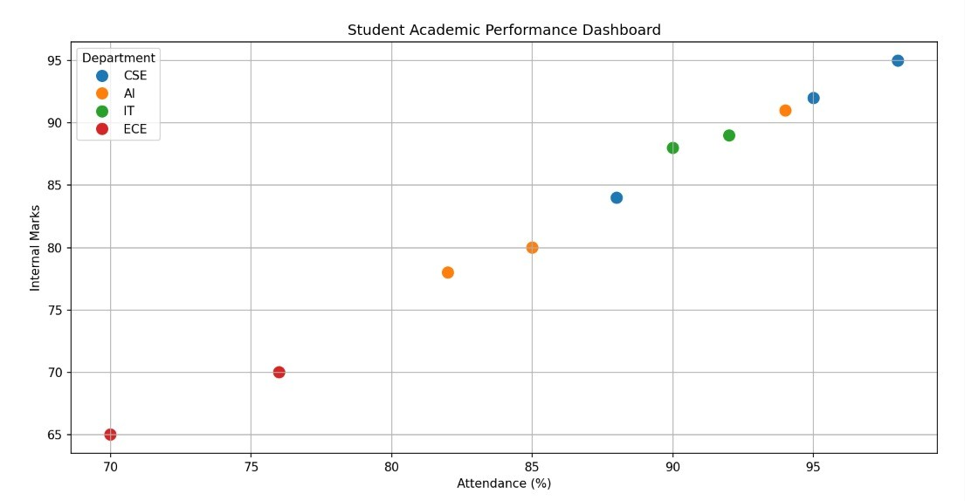
Scenario 2: Electric Vehicle Market Analysis
Code:
# Colors
colors = {
'Tata':'red',
'MG':'blue',
'BYD':'green',
'Hyundai':'orange',
'Mahindra':'purple'
}
plt.figure(figsize=(9,6))
for company in colors:
temp = df[df['Manufacturer'] == company]
plt.scatter(
temp['Battery_Capacity'],
temp['Price'],
s=temp['Driving_Range']/2, # Smaller bubble size
color=colors[company],
edgecolors='black', # Black border
linewidth=1,
alpha=0.7,
label=company
)
plt.title("Electric Vehicle Market Analysis", fontsize=15)
plt.xlabel("Battery Capacity (kWh)", fontsize=12)
plt.ylabel("Price (Lakhs ₹)", fontsize=12)

plt.xticks(range(20,71,5))
plt.yticks(range(5,36,5))
plt.grid(True, linestyle='--', alpha=0.5)
plt.legend(title="Manufacturer")
plt.tight_layout()
plt.show()
Output:
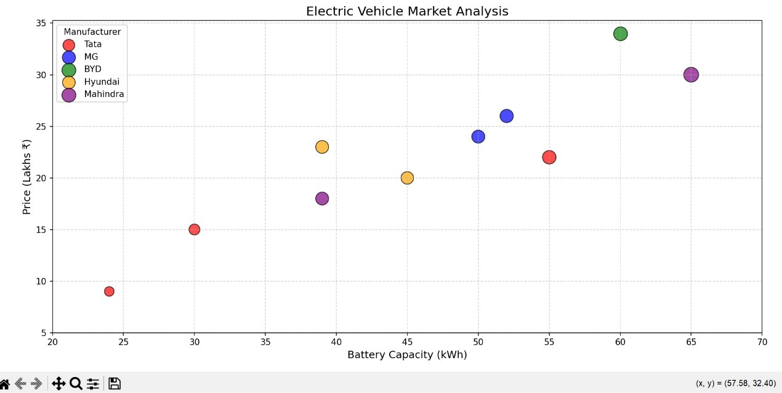
Scenario 3: Hospital Patient Admission Analysis
Code:
import pandas as pd
import matplotlib.pyplot as plt
# Create Dataset
data = {
'Department': ['Cardiology', 'Neurology', 'Orthopedics',
'Pediatrics', 'General Medicine', 'Oncology'],
'Number_of_Patients': [180, 140, 200, 160, 250, 120],
'Average_Treatment_Cost': [85000, 95000, 70000,
50000, 60000, 120000]
}
df = pd.DataFrame(data)
# Plot
plt.figure(figsize=(10,6))
colors = ['red', 'blue', 'green', 'orange', 'purple', 'cyan']

bars = plt.bar(df['Department'],
df['Number_of_Patients'],
color=colors,
edgecolor='black')
# Display treatment cost on bars
for bar, cost in zip(bars, df['Average_Treatment_Cost']):
plt.text(bar.get_x() + bar.get_width()/2,
bar.get_height() + 5,
f'₹{cost}',
ha='center',
fontsize=9,
fontweight='bold')
plt.title("Hospital Patient Admission Analysis", fontsize=15)
plt.xlabel("Department", fontsize=12)
plt.ylabel("Number of Patients", fontsize=12)
plt.grid(axis='y', linestyle='--', alpha=0.5)
plt.tight_layout()
plt.show()
Output:
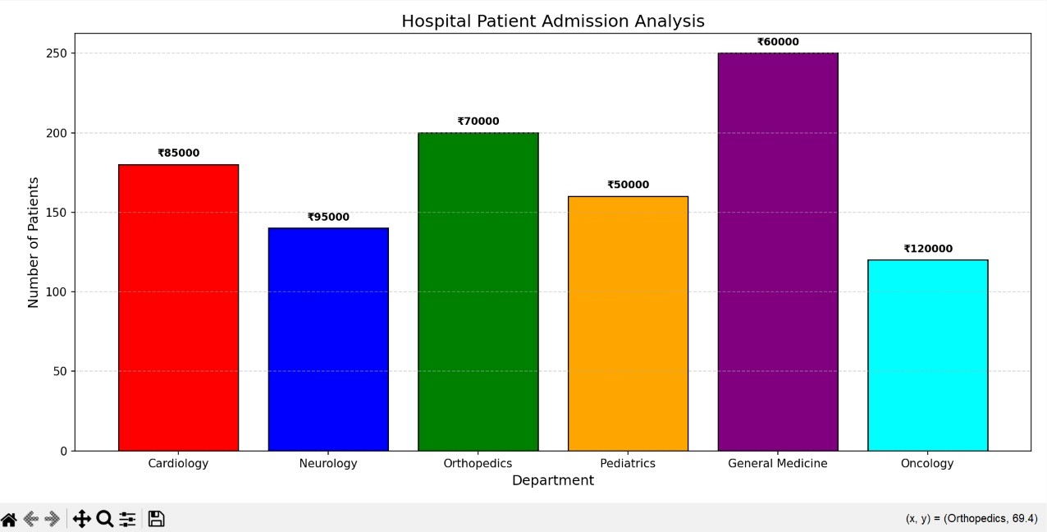

Scenario 4: Weather Monitoring System
Code:
import pandas as pd
import matplotlib.pyplot as plt
# Create Dataset
data = {
'Date': list(range(1, 11)),
'Delhi': [35, 36, 34, 37, 38, 39, 40, 39, 38, 37],
'Mumbai': [30, 31, 31, 32, 33, 32, 31, 30, 30, 31],
'Chennai': [33, 34, 35, 35, 36, 37, 36, 35, 34, 33]
}
df = pd.DataFrame(data)
# Create Figure
plt.figure(figsize=(10,6))
# Delhi
plt.plot(df['Date'],
df['Delhi'],
color='red',
linestyle='-',
marker='o',
linewidth=2,
label='Delhi')
# Mumbai
plt.plot(df['Date'],
df['Mumbai'],
color='blue',
linestyle='--',
marker='s',
linewidth=2,
label='Mumbai')
# Chennai
plt.plot(df['Date'],
df['Chennai'],
color='green',
linestyle=':',
marker='^',
linewidth=2,
label='Chennai')
# Chart Details
plt.title("Weather Monitoring System", fontsize=16)
plt.xlabel("Date", fontsize=12)
plt.ylabel("Temperature (°C)", fontsize=12)
plt.xticks(range(1,11))
plt.yticks(range(28,42))
plt.grid(True, linestyle='--', alpha=0.5)
plt.legend(title="City")
plt.tight_layout()
plt.show()
Output:
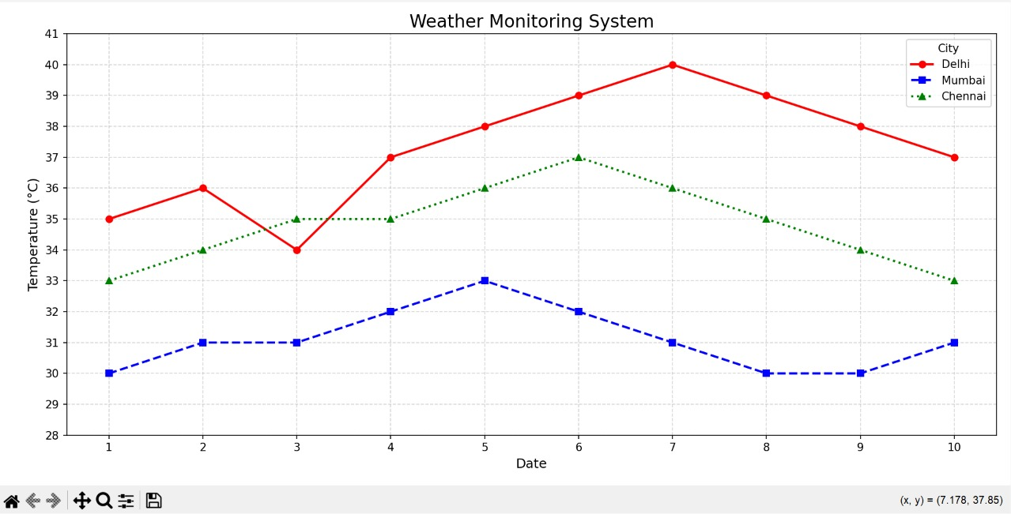
Scenario 5: Supermarket Sales Analysis
Code:
import pandas as pd
import matplotlib.pyplot as plt
import numpy as np
# Create Dataset
data = {
'Product_Category': ['Groceries', 'Beverages', 'Snacks', 'Dairy', 'Household'],
'Branch_A': [120, 90, 70, 80, 60],
'Branch_B': [110, 95, 75, 85, 65],
'Branch_C': [130, 100, 80, 90, 70]
}
df = pd.DataFrame(data)
# Position of bars
x = np.arange(len(df['Product_Category']))
width = 0.25
plt.figure(figsize=(10,6))
# Grouped Bars
plt.bar(x - width,
df['Branch_A'],
width,
label='Branch A',
color='skyblue',
edgecolor='black')
plt.bar(x,
df['Branch_B'],
width,
label='Branch B',
color='lightgreen',
edgecolor='black')
plt.bar(x + width,
df['Branch_C'],
width,
label='Branch C',
color='salmon',
edgecolor='black')
# Labels and Title
plt.title("Supermarket Sales Analysis", fontsize=16)
plt.xlabel("Product Category", fontsize=12)
plt.ylabel("Sales Amount (in ₹ Thousands)", fontsize=12)
plt.xticks(x, df['Product_Category'])
plt.grid(axis='y', linestyle='--', alpha=0.5)
plt.legend(title="Branch")
plt.tight_layout()
plt.show()
Output:
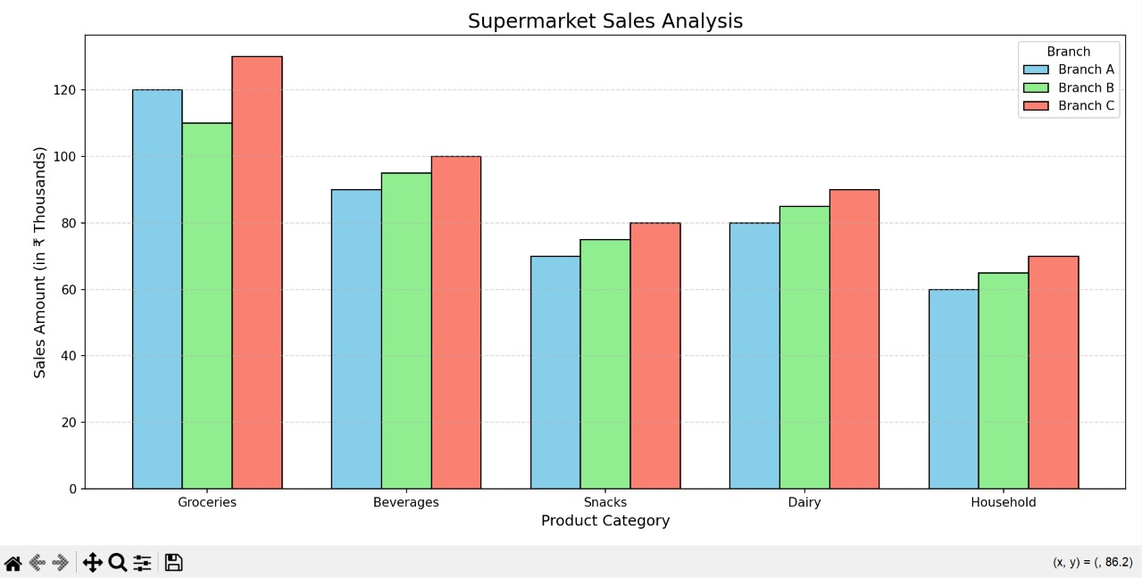
Scenario 6: Employee Salary Distribution
Code:
import matplotlib.pyplot as plt

# Employee Salary Dataset (in ₹)
salary = [
25000, 28000, 30000, 32000, 35000,
38000, 40000, 42000, 45000, 47000,
50000, 52000, 55000, 58000, 60000,
62000, 65000, 68000, 70000, 75000
]
# Create Histogram
plt.figure(figsize=(8,6))
plt.hist(
salary,
bins=8,
color="skyblue",
edgecolor="black"
)
# Title and Labels
plt.title("Employee Salary Distribution")
plt.xlabel("Salary (₹)")
plt.ylabel("Number of Employees")
# Grid
plt.grid(axis='y', linestyle='--', alpha=0.6)
plt.show()
Output:
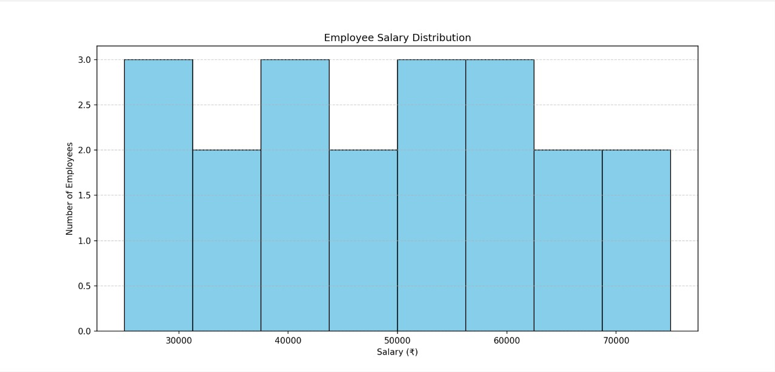
Scenario 7: Smartphone Market Comparison
Code:
import pandas as pd
import matplotlib.pyplot as plt
# Dataset
data = {
'Brand': ['Samsung','Apple','OnePlus','Xiaomi','Vivo','Oppo'],
'RAM': [8,6,12,8,8,12],
'Processor_Speed': [2.8,3.2,3.1,2.7,2.6,3.0],
'Price': [55000,90000,60000,35000,30000,45000],
'Storage': [128,256,256,128,128,256]
}
df = pd.DataFrame(data)
markers = {
'Samsung':'o',
'Apple':'s',
'OnePlus':'^',
'Xiaomi':'D',
'Vivo':'P',
'Oppo':'X'
}
plt.figure(figsize=(8,6))
# Plot each point
for i, row in df.iterrows():
sc = plt.scatter(
row['RAM'],
row['Price'],
s=row['Storage']*2,
c=[row['Processor_Speed']], # Notice the square brackets
cmap='viridis',
marker=markers[row['Brand']],
edgecolors='black'
)
# Brand name beside each point
plt.text(row['RAM']+0.1,
row['Price'],
row['Brand'],
fontsize=9)
# Color Bar
plt.colorbar(sc, label="Processor Speed (GHz)")
# Labels
plt.title("Smartphone Market Comparison")
plt.xlabel("RAM (GB)")
plt.ylabel("Price (₹)")
plt.grid(True)
plt.tight_layout()
plt.show()
Output:
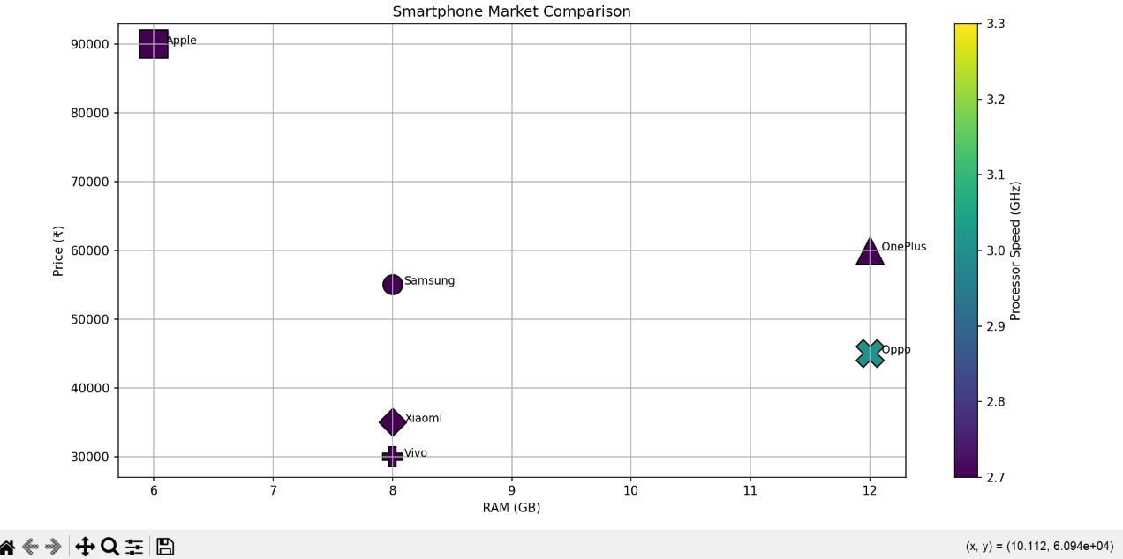
Scenario 8: Online Movie Rating Analysis
Code:
import pandas as pd
import matplotlib.pyplot as plt
import seaborn as sns
# Create Dataset
data = {
'Genre': ['Action', 'Comedy', 'Drama', 'Horror', 'Sci-Fi'],
'2021': [4.2, 3.8, 4.5, 3.6, 4.4],
'2022': [4.3, 3.9, 4.6, 3.7, 4.5],
'2023': [4.4, 4.0, 4.7, 3.8, 4.6],
'2024': [4.5, 4.1, 4.8, 3.9, 4.7]
}
df = pd.DataFrame(data)
# Set Genre as index
df.set_index('Genre', inplace=True)
# Plot Heatmap
plt.figure(figsize=(8,6))
sns.heatmap(
df,
annot=True,
cmap='YlOrRd',
linewidths=0.5,
fmt=".1f"
)
plt.title("Online Movie Rating Analysis")
plt.xlabel("Release Year")
plt.ylabel("Movie Genre")
plt.tight_layout()
plt.show()

Output:
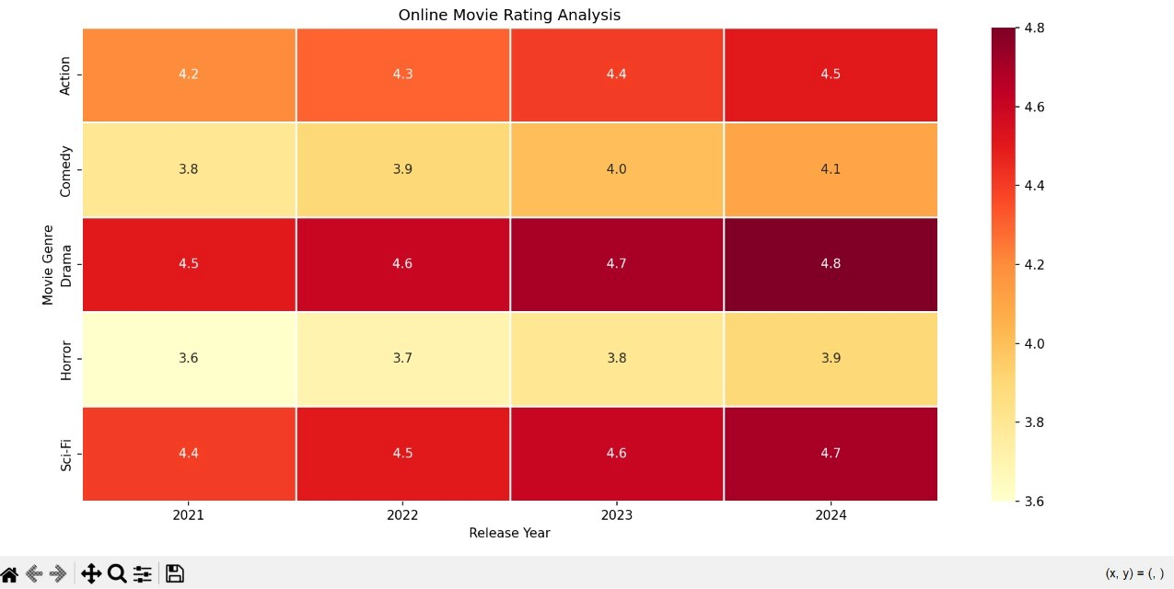

Scenario 9: COVID-19 State-wise Analysis
Code:
import pandas as pd
import matplotlib.pyplot as plt
import seaborn as sns
# Create Dataset
data = {
'State': ['Andhra Pradesh', 'Tamil Nadu', 'Karnataka',
'Kerala', 'Maharashtra', 'Telangana',
'Delhi', 'Gujarat'],

'Active_Cases': [5200, 4100, 3800, 6200, 7100, 2900, 1800, 2600]
}
# Create DataFrame
df = pd.DataFrame(data)
# Set State as Index
df.set_index('State', inplace=True)

# Plot Heatmap (Tile Plot)
plt.figure(figsize=(6,6))
sns.heatmap(
df,
annot=True,
cmap='Reds',
linewidths=1,
linecolor='black',
fmt='d'
)

plt.title("COVID-19 State-wise Active Cases")
plt.xlabel("Active Cases")
plt.ylabel("States")
plt.tight_layout()
plt.show()
Output:
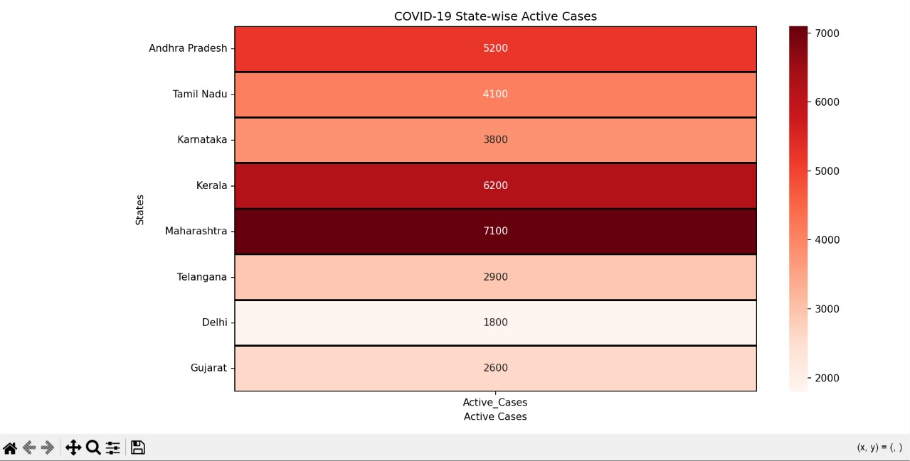

Scenario 10: Iris Flower Classification
Code:
from sklearn.datasets import load_iris
import pandas as pd
import matplotlib.pyplot as plt
# Load Built-in Iris Dataset
iris = load_iris()
# Create DataFrame
df = pd.DataFrame(
iris.data,
columns=['Sepal_Length', 'Sepal_Width',
'Petal_Length', 'Petal_Width']
)
# Add Species Names
df['Species'] = [iris.target_names[i] for i in iris.target]
# Colors and Markers
colors = {
'setosa': 'red',
'versicolor': 'blue',
'virginica': 'green'
}
markers = {
'setosa': 'o',
'versicolor': 's',
'virginica': '^'
}
plt.figure(figsize=(8,6))
# Plot Each Species
for species in df['Species'].unique():
temp = df[df['Species'] == species]
plt.scatter(
temp['Sepal_Length'],
temp['Petal_Length'],
s=temp['Sepal_Width'] * 40, # Point Size
color=colors[species], # Color
marker=markers[species], # Shape
edgecolors='black',
alpha=0.7,
label=species
)
# Labels and Title
plt.title("Iris Flower Classification")
plt.xlabel("Sepal Length (cm)")
plt.ylabel("Petal Length (cm)")
# Legend
plt.legend(title="Species")
# Grid
plt.grid(True, linestyle='--', alpha=0.5)
plt.tight_layout()
plt.show()
Output:
